**Bonus**

**1）**

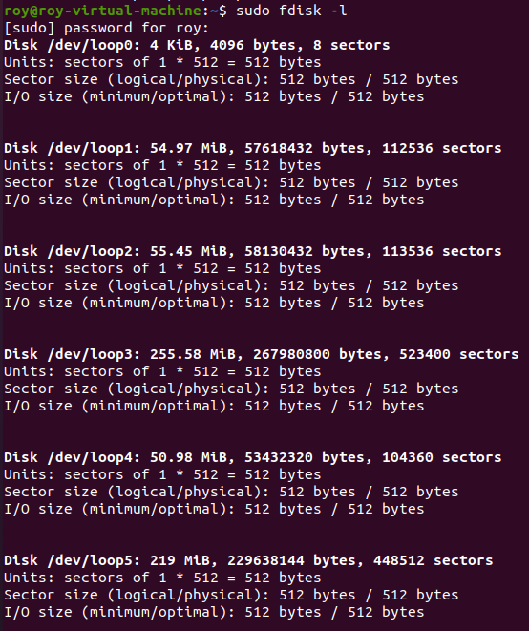

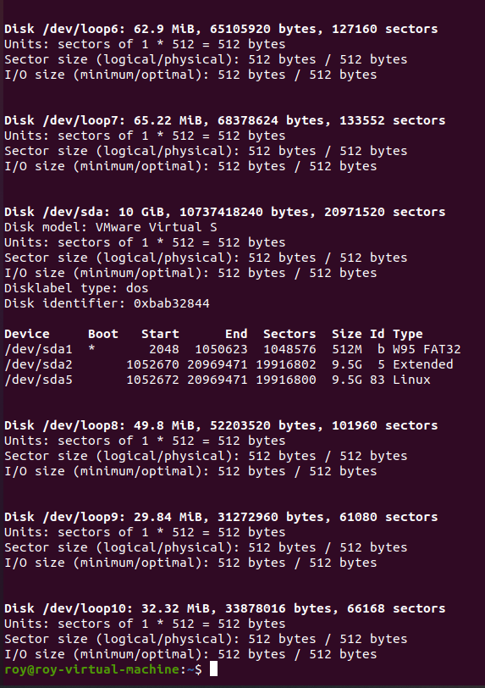

**There are 13 storage devices in my computer. Name: loop1, loop2, loop3, loop4, loop5, loop6, loop7, loop8, loop9, loop10, sda1, sda2 and sda5. As for partition, there are 3 partitions. Name: sda1, sda2, sda5 which sda1 and sda2 are extended partitions and sda5 is logical partition.**

**2)**

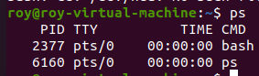

**Command: “ps”**



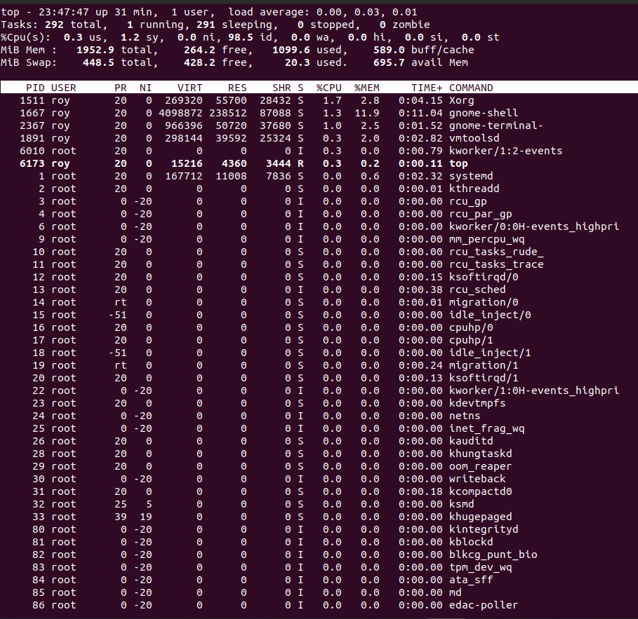

**Command: “top”**

**3)**

**The Linux management command “sudo” permits a user to executes some or all “root” commands by the system controller. “Root” user is the only one super user in the system. It have all the authorities to execute any command.**

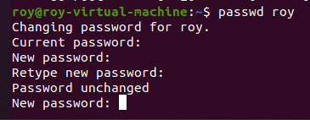

**The command “passwd [account name]” can change password. (The screenshot doesn’t change the passwd.)**

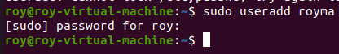

**The command “sudo useradd [new account name]” can create a new account.**

**4)**

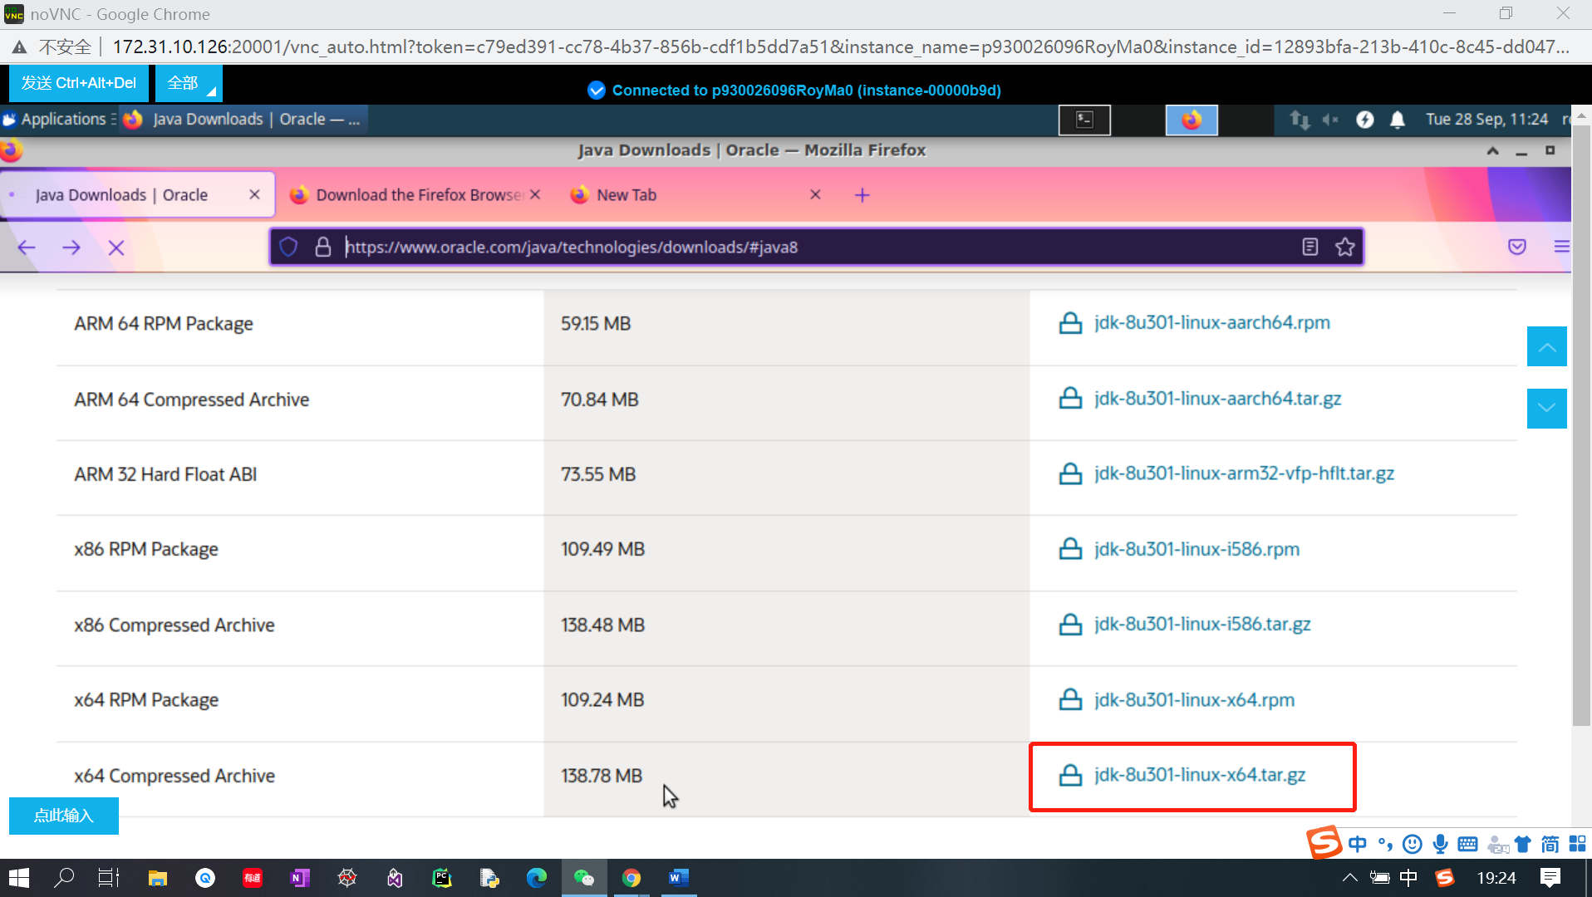

**Go to Oracle and download the compressed archive with the postfix “.tar.gz”**

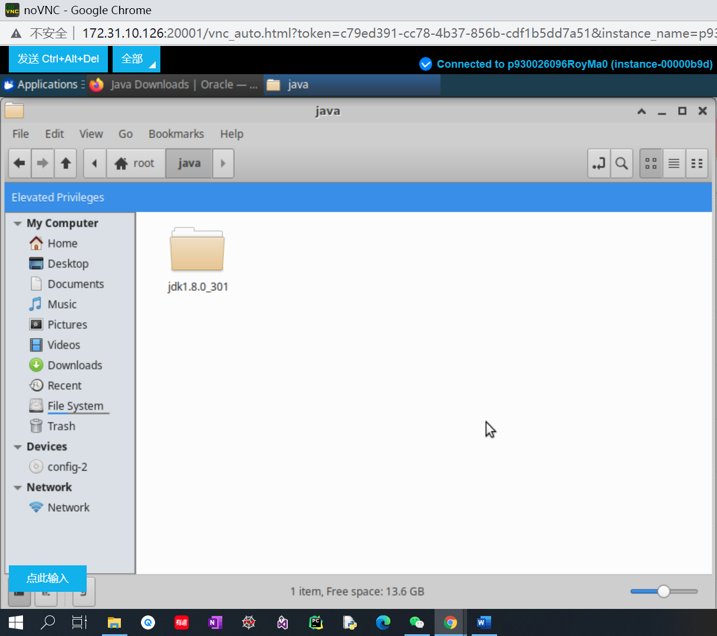

**Extract the archive to a directory called “java”.**

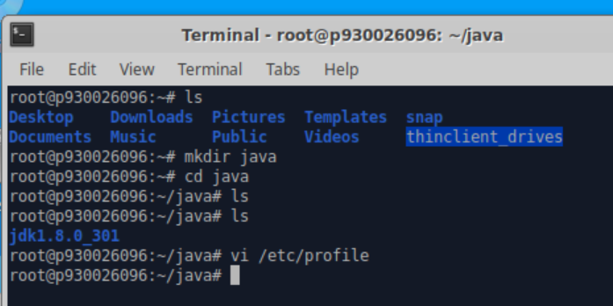

**Create a directory “java” and the extracted file is under such directory.**

**Add the environment variables by editing the file “/etc/profile”.**

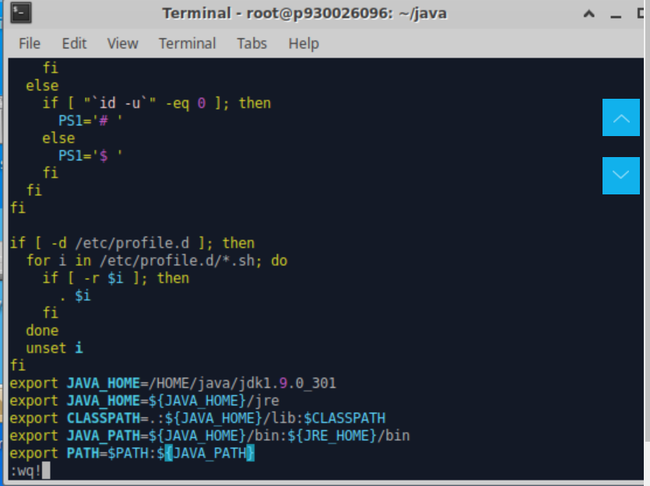

**Add five lines of “export” command at the end of the file. (“i”: insert mode, “Esc”: read mode, “x”: delete one word under read mode, “:wq”: save and exit the file under read mode).**

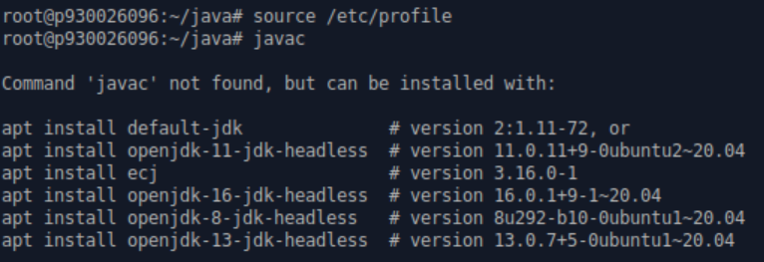

**The first line command is to make the changes in “/etc/profile” valid and check whether the changes has been taken. But, it first need to install some packages.**

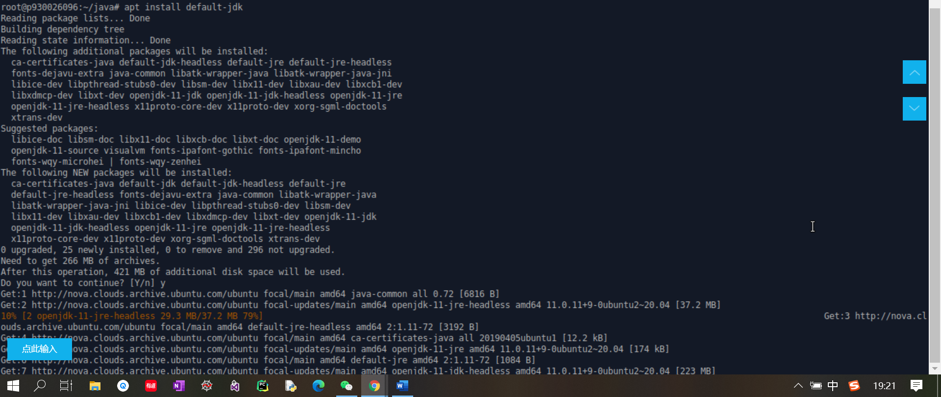

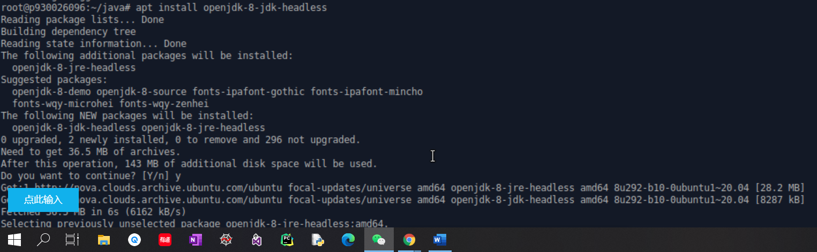

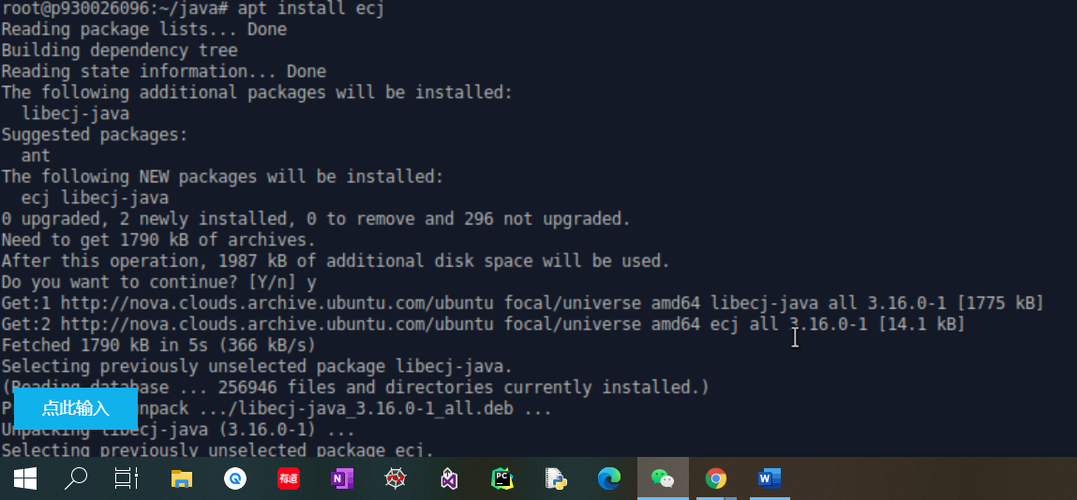

**Install all the needed packages.**

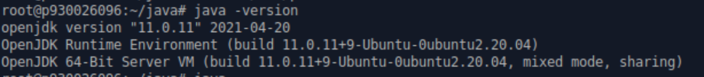

**Check whether environment variable works**

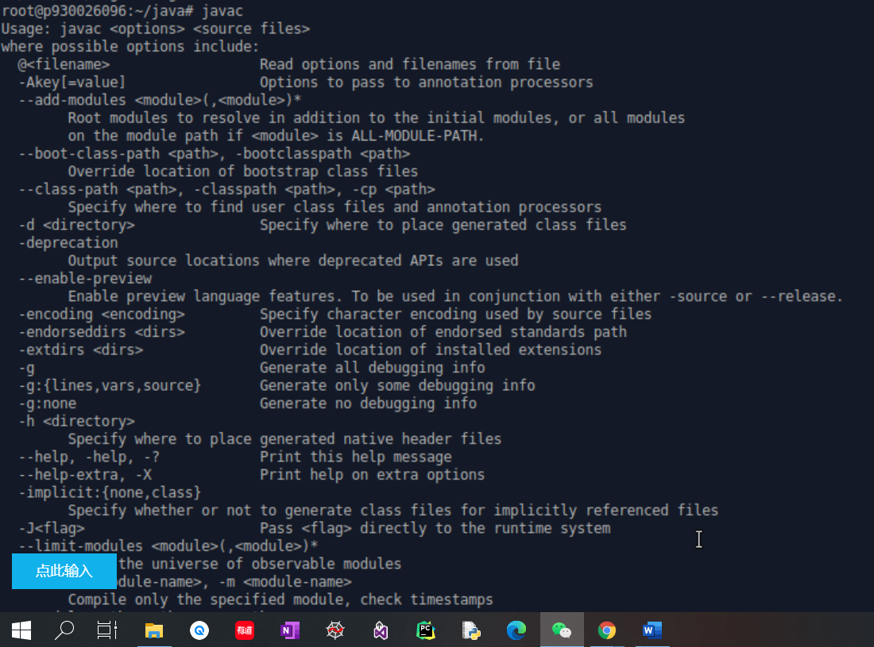

**Java is installed and configured successfully.**

**5）**

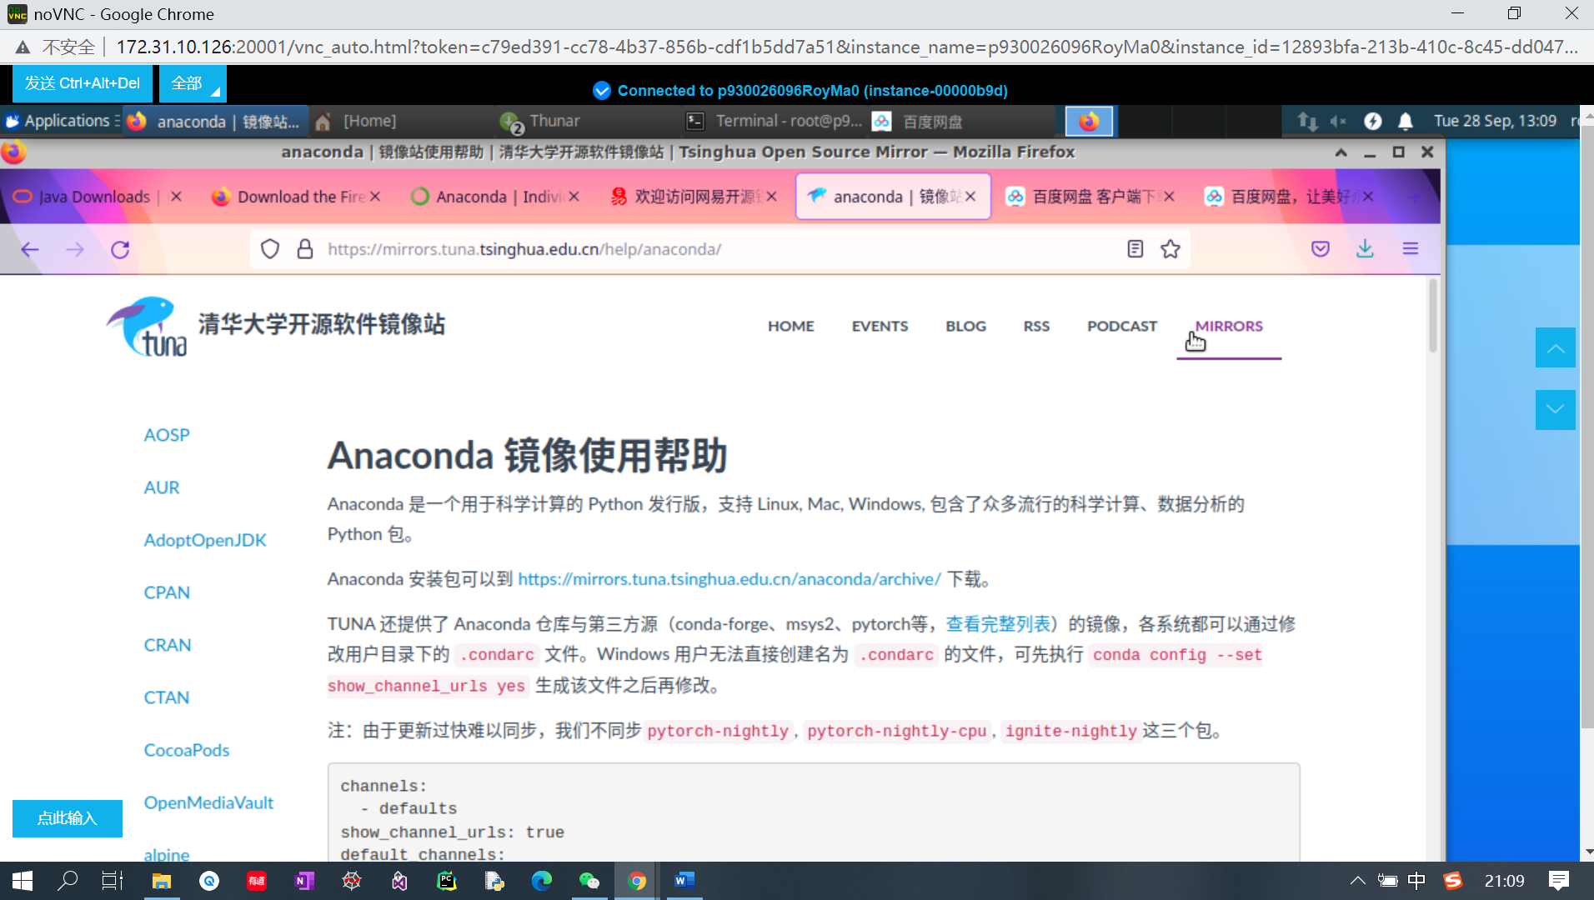

**Find the image file of anaconda in a local source website.**

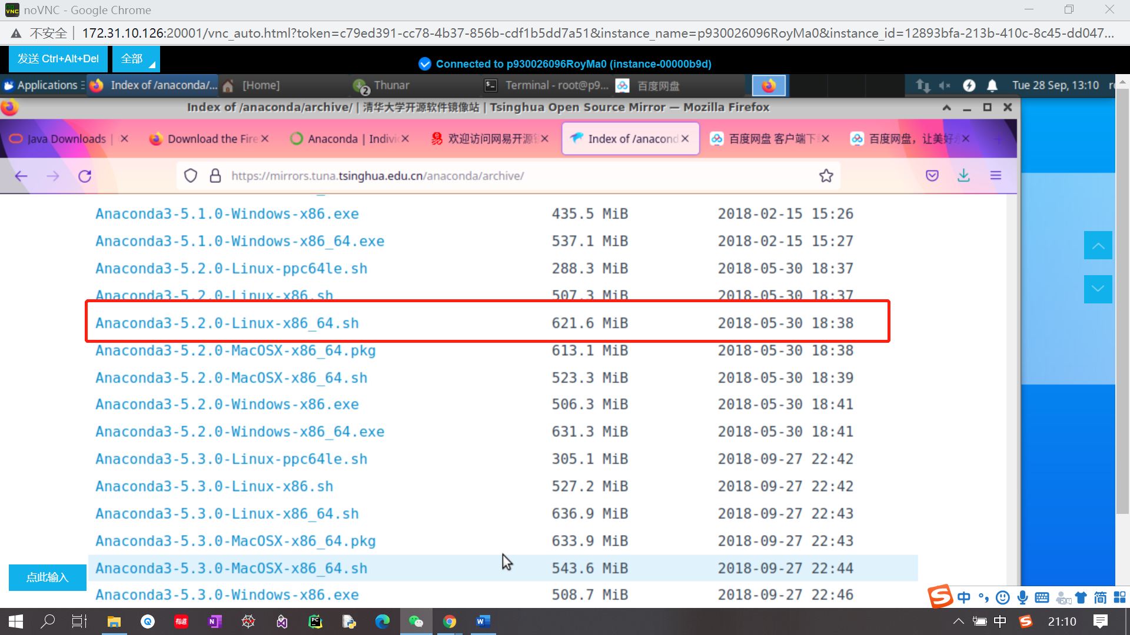

**Download for Linux**

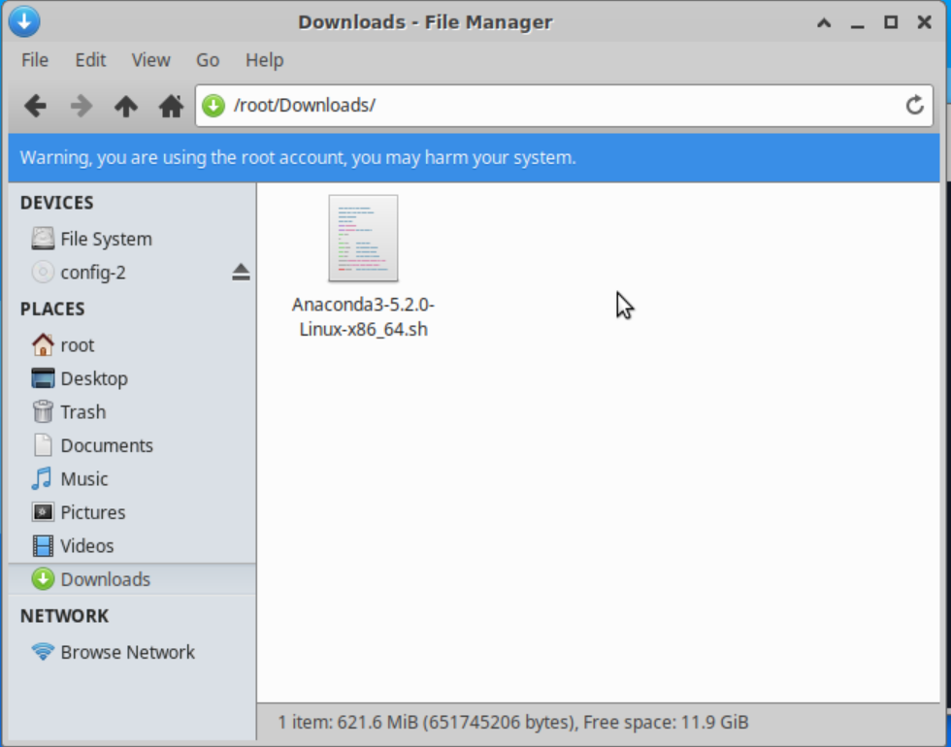

**Check the .sh file in the downloads directory, if not, move it from /tmp to /root/Downloads**

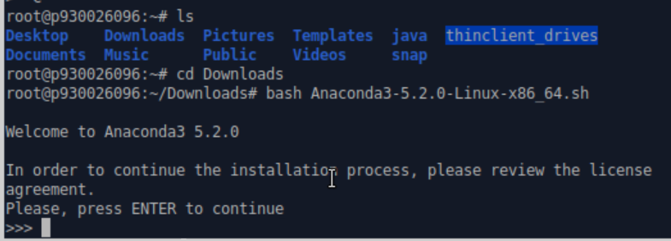

**Enter the Downloads directory and bash the .sh file. Click enter.**

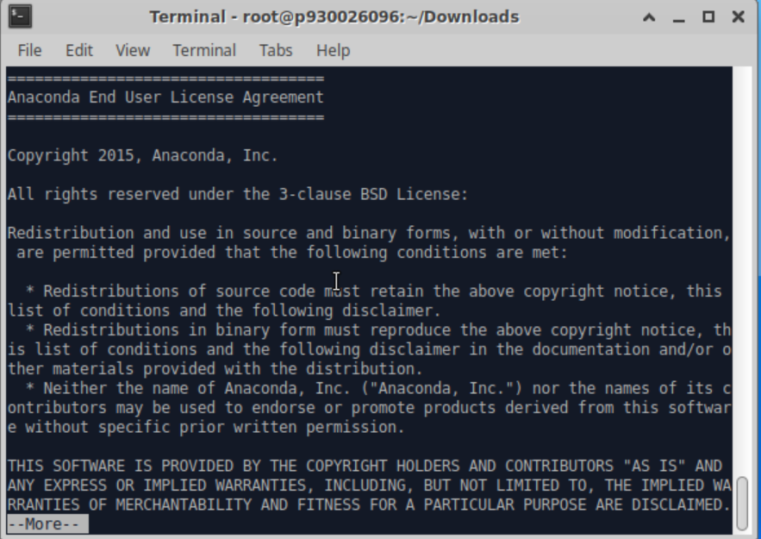

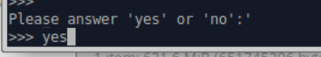

**Type “yes”. All above is the basic information of anaconda.**

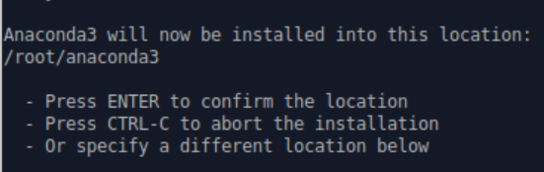

**Click “Enter”.**

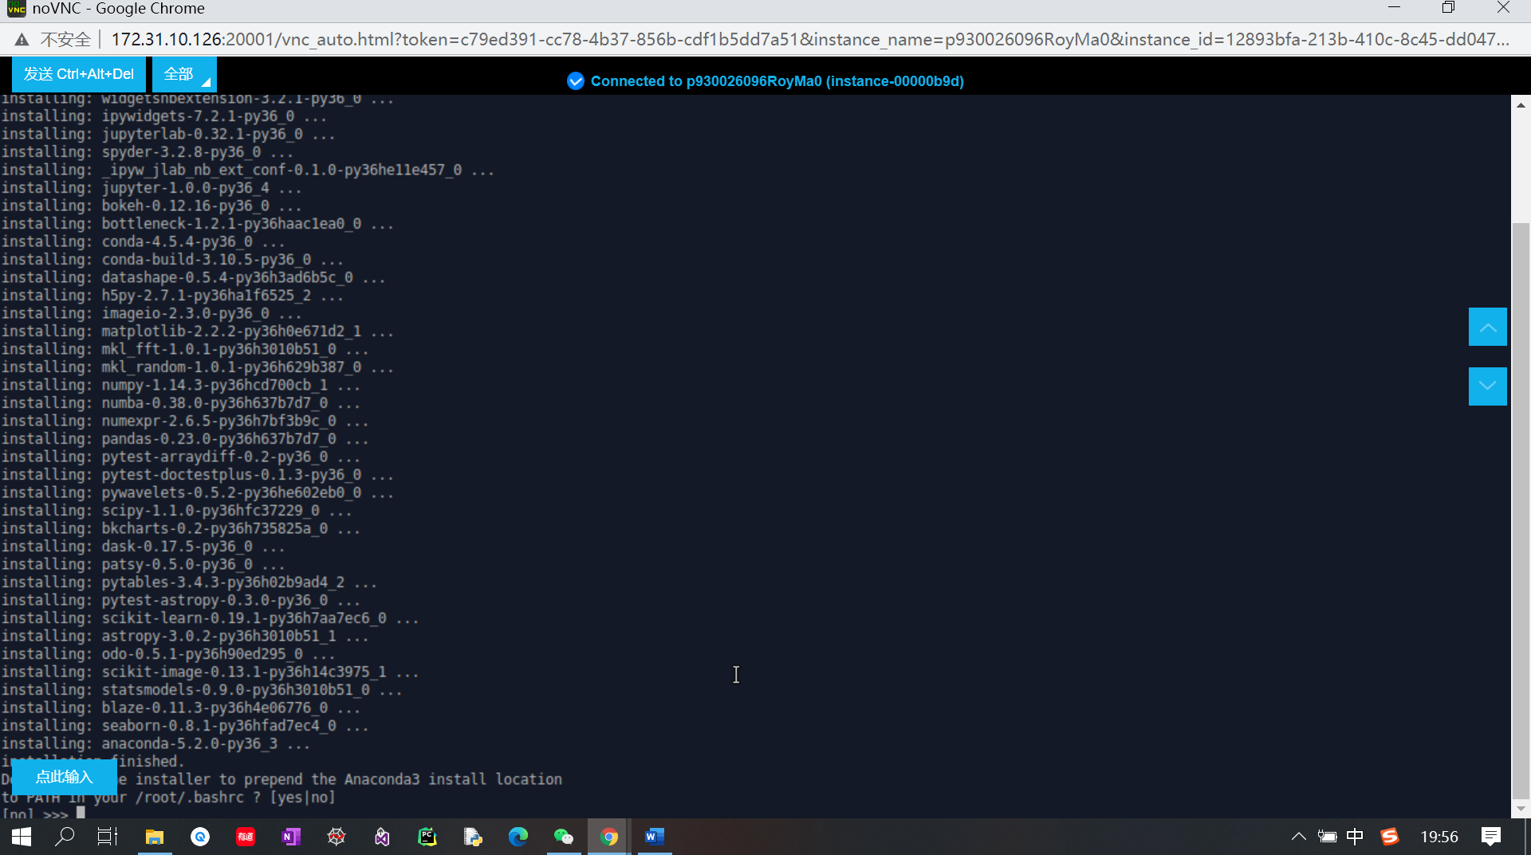

**Type “yes”.**

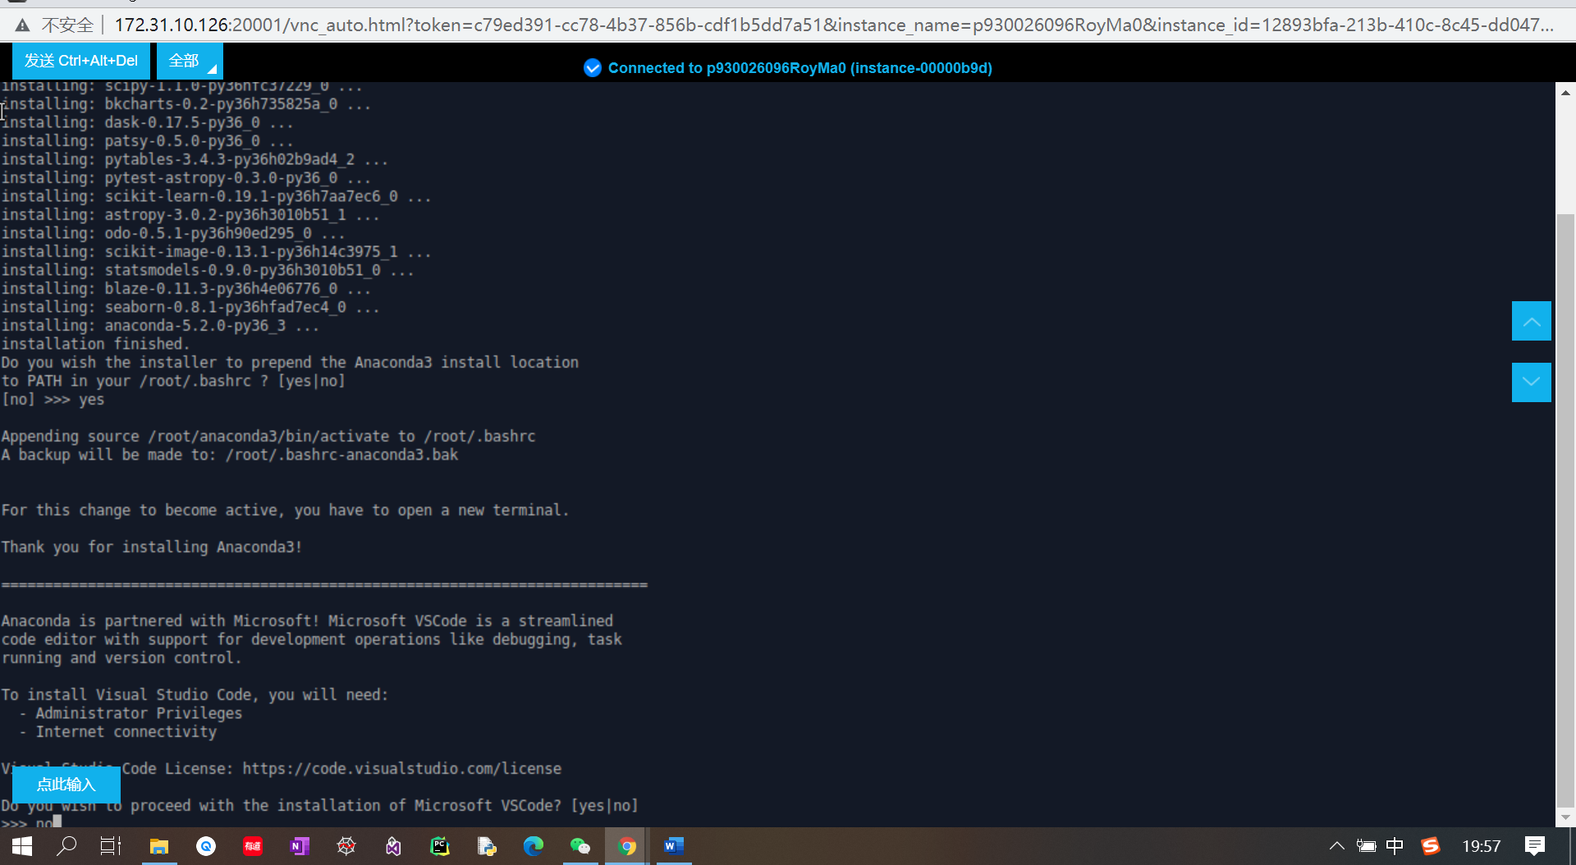

**Type “No”**

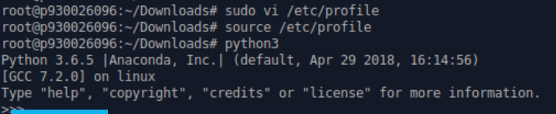

**Configure environmental variable by editing “/etc/profile”. And check the environmental variable by command “Python3”.**

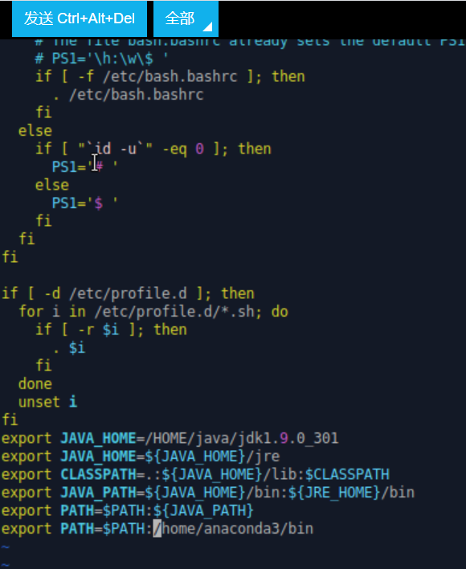

**Add last line to the file. Then save and quit.**

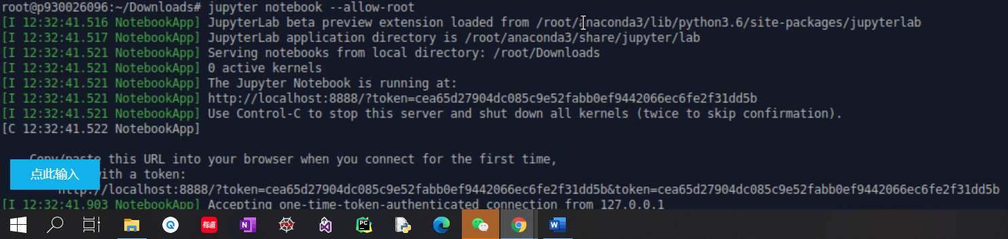

**Open jupyter notebook.**

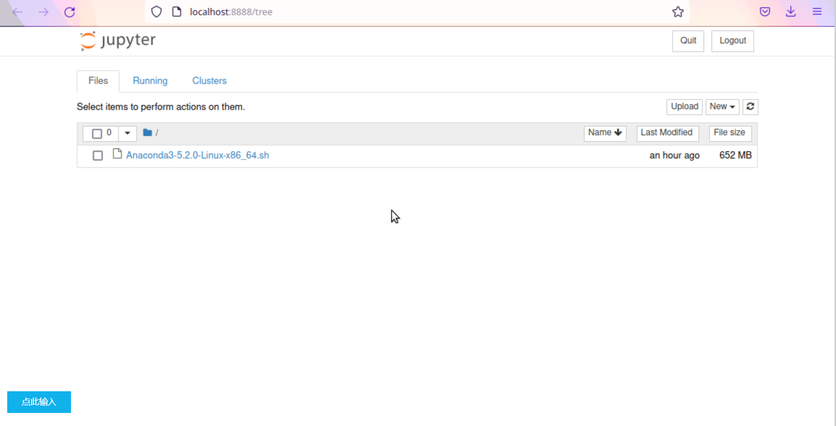

**Successfully open the jupyter notebook.**

**6）**

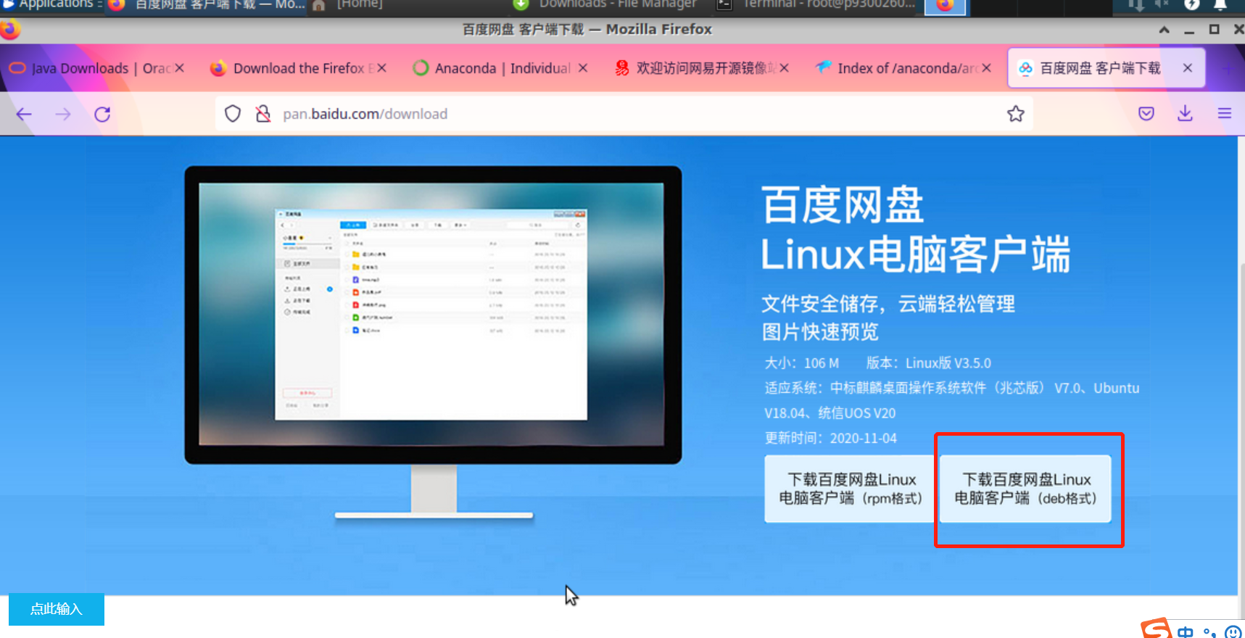

**Go to the official platform of baidunetdisk and download the .deb file for Linux.**

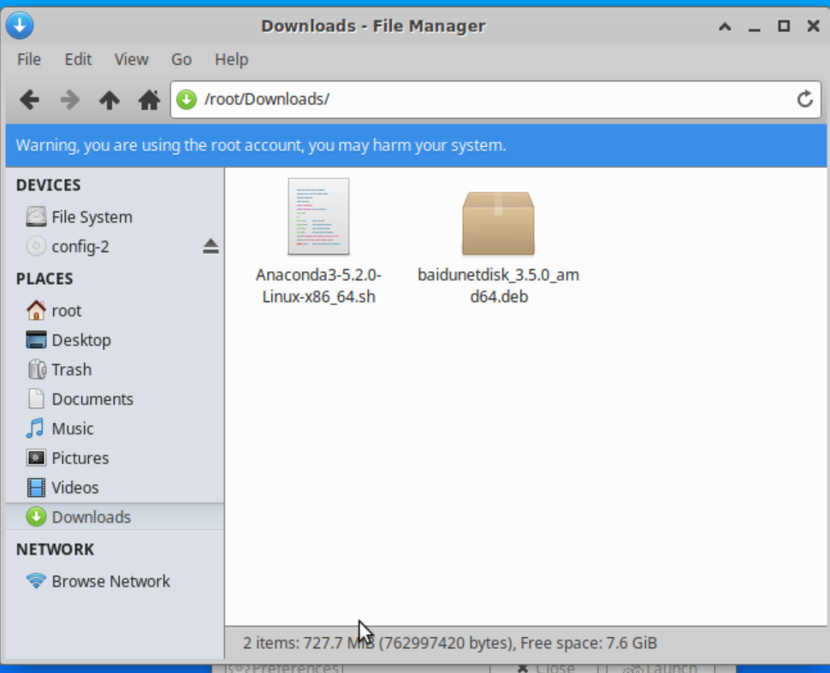

**Move the downloaded file to Downloads directory.**

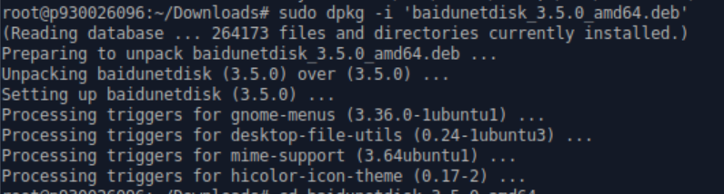

**Unpacking the .deb file.**

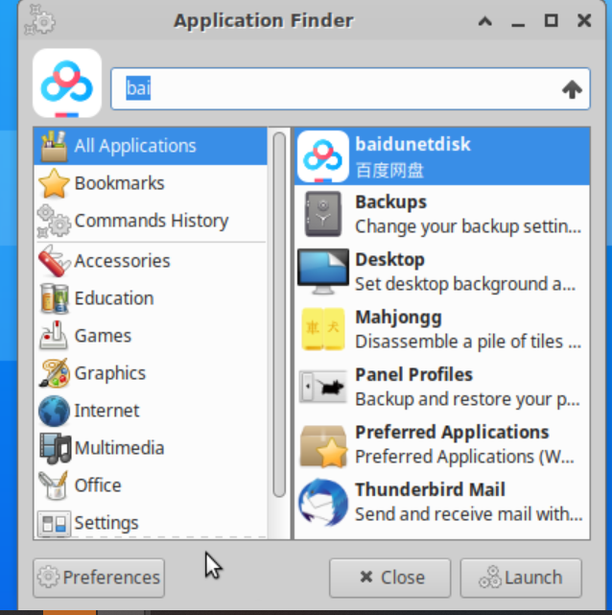

**Find the baidunetdisk in application finder.**

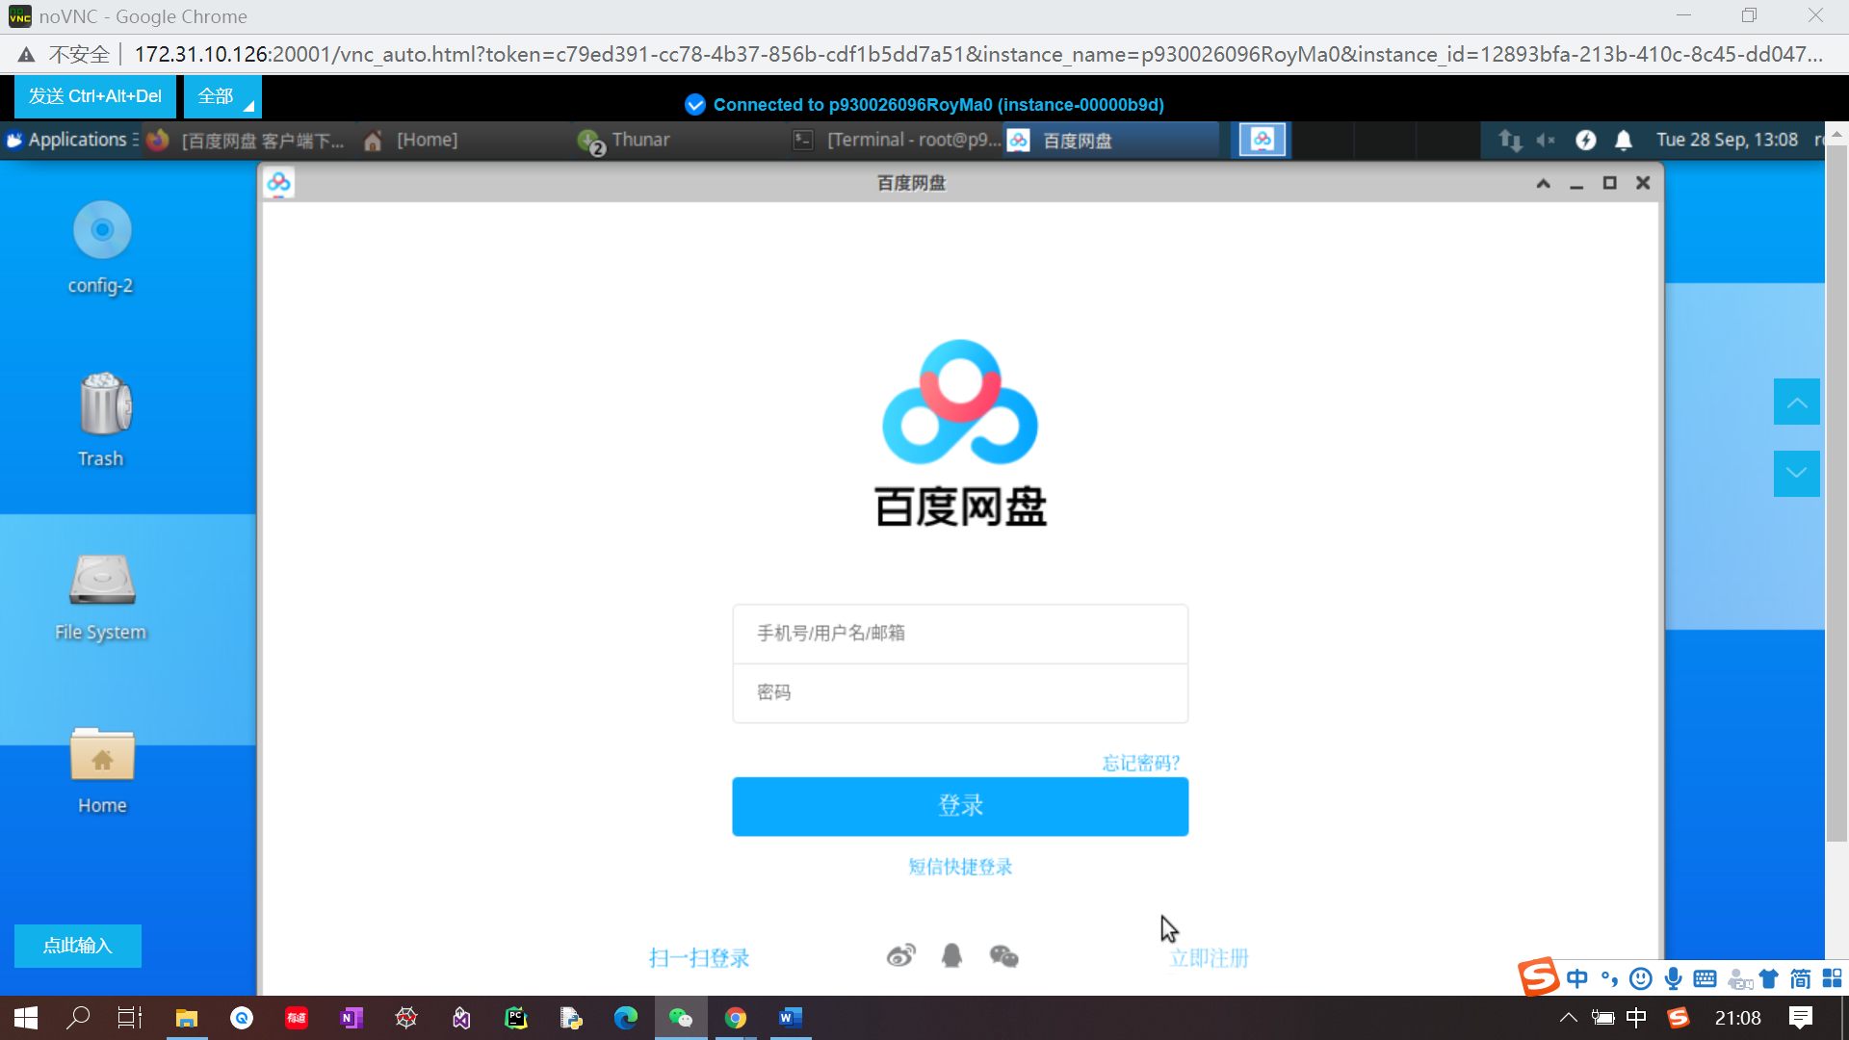

**Successfully download baidunetdisk.**